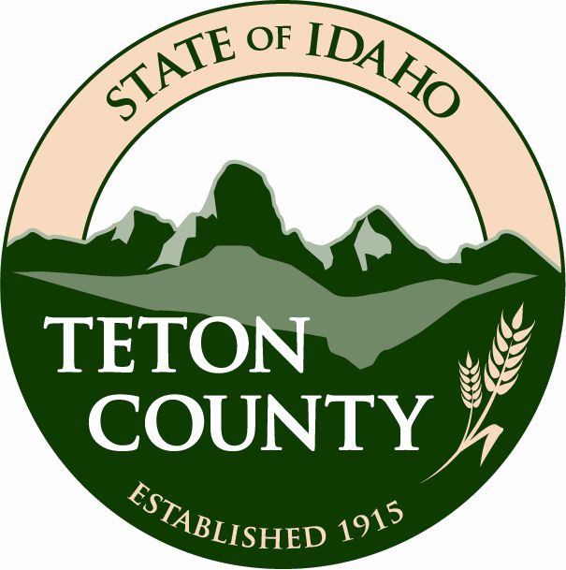
Teton County
Mosquito Abatement District
Board of Trustees
Agenda for 6-20-2013 Meeting
6:30 PM at the Justice Center
89 N. Main, Driggs, ID

- Approve previous minutes
- Claims review
- Financial status
- Financial goals
- NPDES repeal status
- VDCI Report
- Other business

