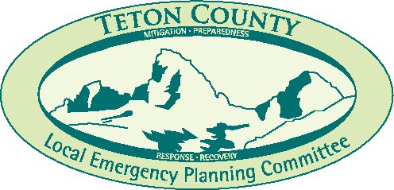

**Teton County LEPC & Citizen Corps Council Agenda**

**Tuesday, October 1, 2024**

**In-Person or Zoom Meeting Time 4:00 PM**

**Teton County Board of County Commissioners Hearing Room**

**150 Courthouse Drive, Driggs, ID**

Sara White, Chair

Emily Bilcher, Vice Chair

Ronn Carlentine, Secretary

I. **Introductions**

II. **Review Previous Meeting Minutes**

Approve the September 3, 2024 Minutes

III. **Old Business**

N/A

IV. **New Business**

1. Teton County Fire & Rescue District

Mike Maltaverne, Overview on 2024 Wildland Fire Season

1. Greater Idaho Healthcare Coalition – Health Grant Items

V. **Agency Reports**

A. Teton County Emergency Management M. American Red Cross

B. Teton County Sheriff N. Teton County Extension Office

C. Teton County Commission O. Eastern Idaho Public Health

D. Teton County Road & Bridge P. Idaho Office of Emergency Management

E. City of Tetonia Q. Teton School District 401

F. City of Driggs R. Idaho Fish & Game

G. City of Victor S. US Forest Service

H. Media Representative T. Mental Health Coalition

I. Teton Valley Hospital U. Community Resource Center

J. Teton County Fire Protection District V. Family Safety Network

K. Teton County Search & Rescue W. Air Idaho

L. Idaho State Police X. Greater Idaho Healthcare Coalition

VI. **Adjournment**

VII **Next Meeting:** November 5, 2024